
Supervised BY:
- ENG: Lila Ahmed

BY :
- Yousif Salah Muhammad
- Asmaa Ali Abdelaaty
- Abdelrahman Osama Mohmed
- Esraa Taha Abdelhasseb
- Aml Abdullah shehata
- Hanan Hamdy Mostafa

Sales forecasting

Introduction
We are students in the Data Science and AI track at DEPI (Digital Egypt Pioneers Initiative), which is a national program in Egypt that provides advanced training in technology and data-related fields.
As part of our graduation project, we wanted to work on real-world data to gain practical experience. That’s why we chose the Rossmann Store Sales dataset, since it provides a rich and realistic business case for applying data science and AI techniques.

About us
We are students in the IBM Data Science track at DEPI (Digital Egypt Pioneers Initiative).
Team Members
- Yousif Salah Muhammad
- Asmaa Ali Abdelaaty
- Abdelrahman Osama Mohmed
- Esraa Taha Abdelhasseb
- Aml Abdullah shehata
- Hanan Hamdy Mostafa

Project goal
To predict daily sales for Rossmann stores and produce a reproducible pipeline demonstrating data cleaning, feature engineering, model selection, evaluation, and a deployment-ready forecast solution. The project focuses on both predictive performance and actionable business insights (promotions, seasonality, competition).

About Rossmann Store Sales
Rossmann is one of the largest drugstore chains in Europe, headquartered in Germany. It operates thousands of stores across several countries, selling products such as health, beauty, household, and personal care items.
The Rossmann Store Sales dataset was originally released as part of a Kaggle competition. It contains real-world historical sales data from Rossmann stores. The dataset includes information such as:
- Sales figures (daily sales for each store).
- Store details (store type, assortment type, whether it runs promotions, etc.).
- Promotions and marketing campaigns (Promo, Promo2, and their intervals).
- Competition data (distance to the nearest competitor, when competitors opened nearby).
- Dates and holidays (to capture seasonality, weekends, and special events).
This dataset is widely used because it provides a realistic business case: predicting future sales for retail stores. It’s useful for learning and applying:
- Time series forecasting
- Regression models
- Feature engineering
- Optimization for inventory and business decisions

Quick dataset summary (concise)
- train.csv: daily historical records including Sales, Customers, Open, Promo, StateHoliday, SchoolHoliday, Date, Store.
- test.csv: same but without Sales (what we predict).
- store.csv: static store info: StoreType, Assortment, CompetitionDistance, CompetitionOpenSinceMonth/Year, Promo2 fields.
Key modelling target: Sales (predict daily sales for each store-day). On closed days Open=0 sales should be 0.

Source of Dataset
Kaggle
Rossmann Store Sales | Kaggle

Dive into Data
It’s historical sales data for 1,115 Rossmann stores. The task is to forecast the "Sales" column for the test set.
Files
- train.csv - historical data including Sales
- test.csv - historical data excluding Sales
Data fields
Train.csv
historical data including Sales
Store: a unique Id for each store
DayOfWeek: 1 → Monday … 7 → Sunday
Date: YYYY-MM-DD
Sales: the turnover for any given day (this is what you are predicting)
Customers: the number of customers on a given day

Open:
- 0 = closed → sales = Zero
- 1 = open
Promo
- 0 → no
- 1→Yes
- indicates whether a store is running a promo on that day
StateHoliday:
All schools are closed (public holidays , weekends)
- a = public holiday
- b = Easter holiday,
- c = Christmas
- 0 = None
SchoolHoliday: indicates if the (Store, Date) was affected by the closure of public schools
- 0→No
- 1→Yes
store.csv
supplemental information about the stores
Store: a unique Id for each store
StoreType: differentiates between 4 different store models: a, b, c, d
Assortment:
- a = basic
- b = extra
- c = extended

CompetitionDistance: distance in meters to the nearest competitor store
CompetitionOpenSinceMonth: approximate month of the time the nearest competitor was opened

CompetitionOpenSinceYear: approximate Year of the time the nearest competitor was opened
Promo2: Promo2 is a continuing and consecutive promotion for some stores:
- 0 = store is not participating,
- 1 = store is participating
Promo2SinceWeek: describes the week when the store started participating in Promo2
Promo2SinceYear: describes the year and calendar week when the store started participating in Promo2 • DurationPromo2 = CurrentYear - Promo2SinceYear
PromoInterval: describes the consecutive intervals Promo2 is started, naming the months the promotion is started anew. E.g. "Feb,May,Aug,Nov" means each round starts in February, May, August, November of any given year for that store

The first step in our project was to merge the different datasets into a single dataframe to facilitate analysis and modeling.
- We merged train.csv and store.csv on the Store column.
- We applied the same merge to test.csv and store.csv.
This allowed us to enrich each record with additional store information (e.g., store type, assortment, competition, and promotion details).
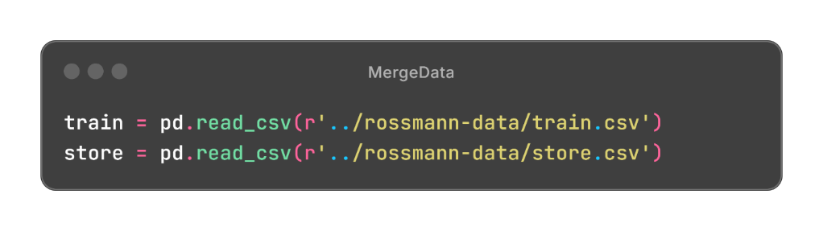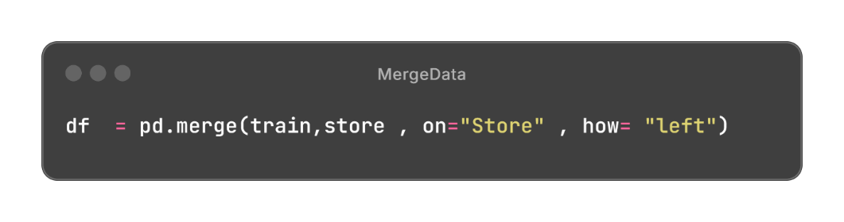
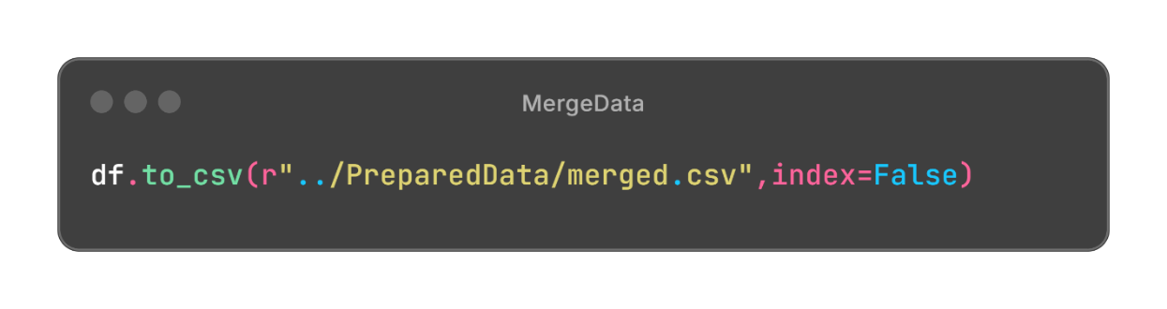

System Design And Analysis



Exploratory Data Analysis (EDA)
is an important step in data analysis which focuses on understanding patterns, trends and relationships

Summary

- Rows: 1,017,209
- Columns: 18
- Goal: Understand and predict store sales based on time, promotions, holidays, and competition.
- Key Targets: Sales
- Key Features: Customers, Promo, StoreType, Assortment, CompetitionDistance, and time-ba otebook or report more organized?

Summary of Dataset

Column Name | Detailed Description | Data Type | Example Values | Missing Values? | Role | Preprocessing & Analytical Notes
Store | Unique ID representing each store. Used to distinguish different stores and can be used for grouping or encoding. | Integer / Categorical | 1, 2, 3, ... | No | Identifier | Not used directly for prediction unless encoded. Useful for grouping (average sales per store) or target encoding.
DayOfWeek | Represents the day of the week (1 = Monday, ..., 7 = Sunday). Captures weekly sales patterns. | Integer (1–7) | 1, 5, 7 | No | Feature | Convert to categorical or cyclical features using sin/cos transformations. Visualize average sales per day of week to detect weekly trends.
Date | The actual calendar date of the record. Used to extract time-related features (year, month, week, etc.). | String → Datetime | 2015-07-31 | No | Feature | Convert to datetime. Extract features such as year, month, day, weekofyear, and weekday. Useful for time series trend analysis.
Sales | Total daily sales for each store — often the target variable in forecasting tasks. | Numeric (Int/Float) | 5263, 13995 | No | Target | Check distribution (may require log transform). Sales are typically zero when the store is closed (Open=0). Remove closed days when training predictive models if needed.
Customers | Number of customers who visited the store that day. Strongly correlated with sales. | Integer | 555, 625, 1498 | No | Feature | Plot Sales vs Customers to verify correlation. Be careful using this feature if predicting future sales, since future customer counts may not be known.
Open | Indicates whether the store was open (1) or closed (0). | Binary (0/1) | 1, 0 | No | Feature / Filter | Use as a filter — most models exclude closed days (Sales=0). Or include as a feature so the model learns zero-sales behavior.
Promo | Whether a short-term promotion was active on that day. | Binary (0/1) | 1, 0 | No | Feature | Promotions usually boost sales; visualize average sales during promo vs. non-promo days.
StateHoliday | Indicates a state-level public holiday. Encoded as: “0” = None, “a” = Public holiday, “b” = Easter, “c” = Christmas. | Categorical (Object) | "0", "a", "b", "c" | No | Feature | Encode with label/one-hot encoding. Analyze sales changes during holidays vs. normal days.
SchoolHoliday | Indicates if the (store’s region) school was closed. | Binary (0/1) | 1, 0 | No | Feature | Useful for modeling foot traffic variations — families might shop differently during school holidays.
StoreType | Type of the store (a, b, c, d). Represents business scale or layout. | Categorical | "a", "b", "c", "d" | No | Feature | Apply one-hot or label encoding. Compare average sales per store type.
Assortment | Type of product assortment: “a” = basic, “b” = extra, “c” = extended. | Categorical | "a", "b", "c" | No | Feature | Encode categorically. Analyze sales differences across assortment types.
CompetitionDistance | Distance to the nearest competitor store (in meters). | Numeric (Float) | 1270.0, 570.0 | Some (≈0.26%) | Feature | Fill missing with median or large placeholder. Investigate correlation between distance and sales — closer competitors may reduce sales.
CompetitionOpenSinceMonth | Month when the nearest competitor started operating. | Numeric (1–12) | 9, 11, 12 | Yes (~32%) | Feature | Missing = competitor info unknown. Combine with Year to create “competition_open_time” feature.
CompetitionOpenSinceYear | Year when the nearest competitor started operating. | Numeric (e.g. 2008, 2007) | 2008, 2007 | Yes (~32%) | Feature | Use with Month to estimate how long the competitor has been open (competition age). Missing values can be filled logically or as “unknown”.
Promo2 | Whether the store is participating in a continuous (long-term) promotion campaign. | Binary (0/1) | 1, 0 | No | Feature | Check how ongoing promotions affect sales. Combine with PromoInterval to detect active months.
Promo2SinceWeek | Week number when continuous promotion started. | Numeric (1–52) | 13, 14 | Yes (~50%) | Feature | Combine with Promo2SinceYear to determine start date of continuous promo. Missing = not in Promo2 program.
Promo2SinceYear | Year when continuous promotion started. | Numeric (e.g. 2010, 2011) | 2010, 2011 | Yes (~50%) | Feature | Missing if store not part of Promo2. Convert with Promo2SinceWeek into actual start date if needed.
PromoInterval | Months when Promo2 is repeated (e.g., “Jan,Apr,Jul,Oct”). | Categorical (Object) | “Jan,Apr,Jul,Oct” | Yes (~50%) | Feature | Parse months into binary indicators for whether the current month is within a promo period.

Columns Summary
NO. | Field Name | dtype | Null values
 | Store | int64 | 0
 | DayOfWeek | int64 | 0
 | Date | object | 0
 | Sales | int64 | 0
 | Customers | int64 | 0
 | Open | int64 | 0
 | Promo | int64 | 0
 | StateHoliday | object | 0
 | SchoolHoliday | object | 0
 | StoreType | object | 0
 | Assortment | object | 0
 | CompetitionDistance | float64 | 2642
 | CompetitionOpenSinceMonth | float64 | 323348
 | CompetitionOpenSinceYear | float64 | 323348
 | Promo2 | int64 | 0
 | Promo2SinceWeek | float64 | 508031
 | Promo2SinceYear | float64 | 508031
 | PromoInterval | object | 508031

Relation Between Columns (Using Correlation Matrix) 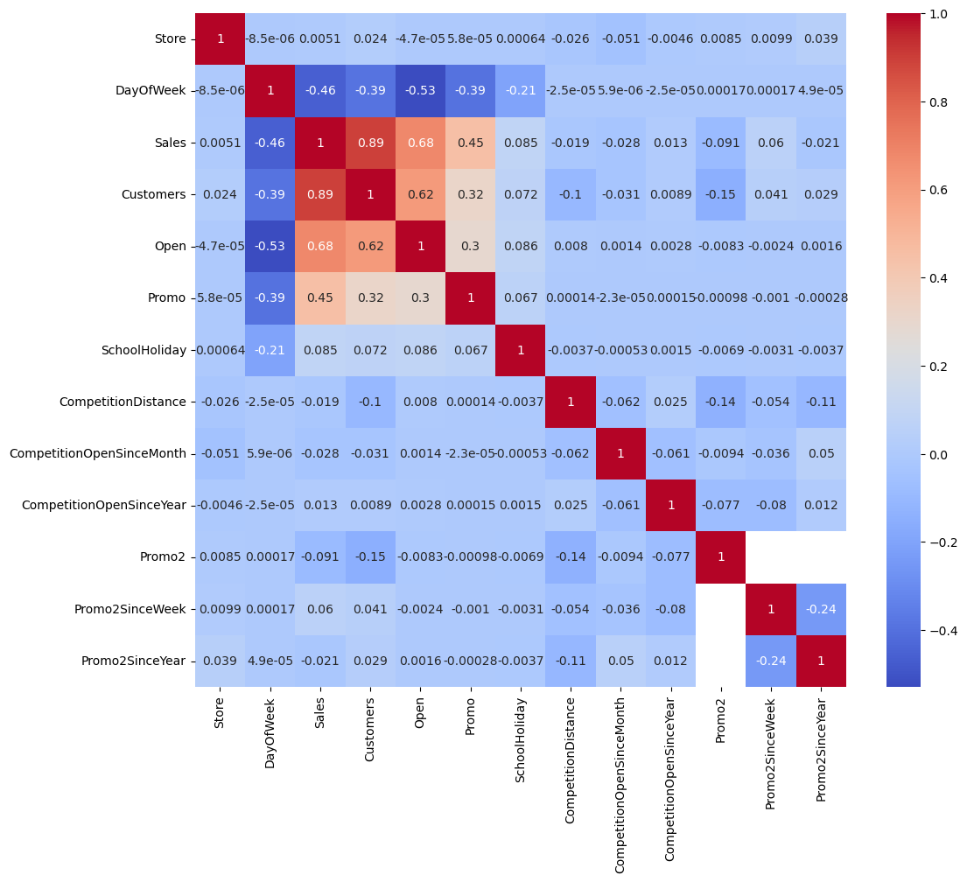
We noticed that The most features affect on the target (Sales) are
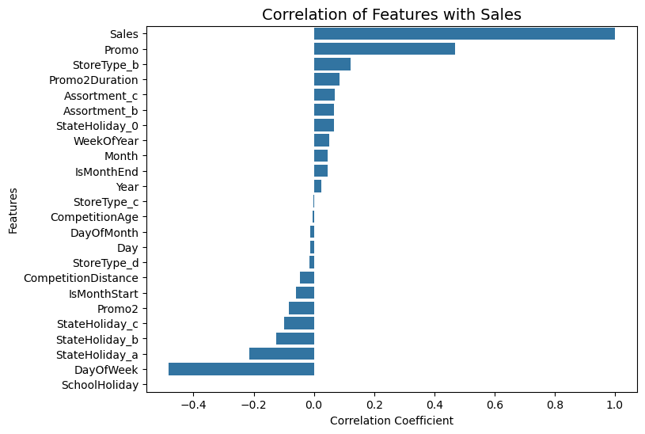
- Customers (0.89)
- Open (0.68)
- DayOfWeek (0.46)
- Promo (0.45)

Data Quality Issues

Missing values
Column | No. of missing values
CompetitionDistance | 2642
CompetitionOpenSinceMonth | 323348
CompetitionOpenSinceYear | 323348
Promo2SinceWeek | 508031
Promo2SinceYear | 508031
PromoInterval | 508031

Outliers
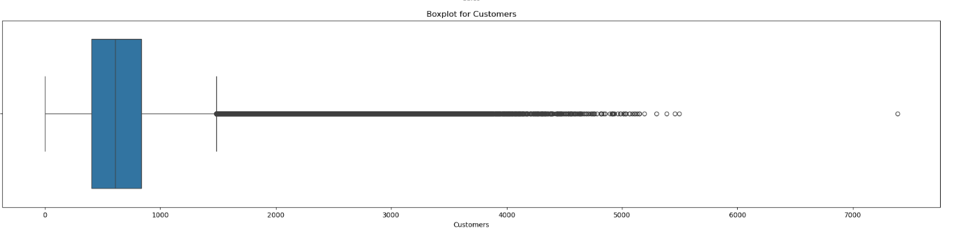

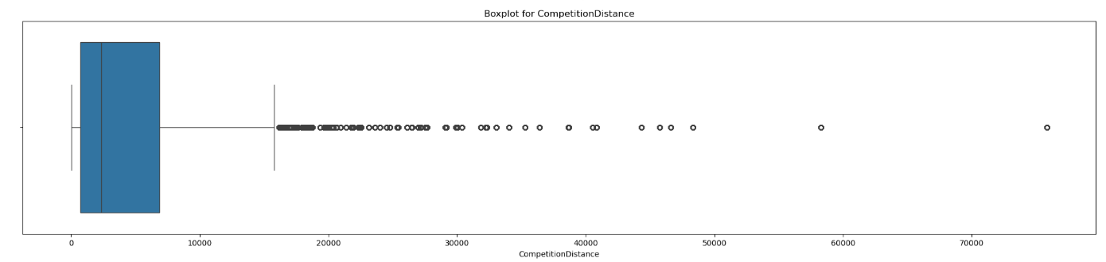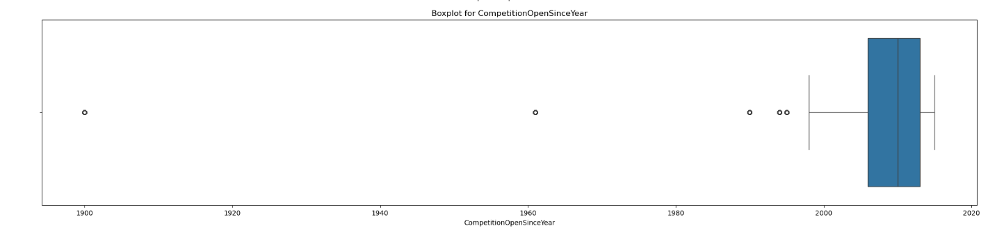

Column | Number of Outliers | Outlier Values (Sample)
Store | 0 | No outliers detected
DayOfWeek | 0 | No outliers detected
Sales | 26,694 | 15344, 14190, 14180, 14949, 14927, 18227, 16191, 17286, 22205, 14096
Customers | 38,095 | 1498, 1586, 2041, 1659, 2508, 2628, 3669, 2316, 2592, 2049
Open | 172,817 | 0, 0, 0, 0, 0, 0, 0, 0, 0, 0
Promo | 0 | No outliers detected
SchoolHoliday | 181,721 | 1, 1, 1, 1, 1, 1, 1, 1, 1, 1
CompetitionDistance | 99,160 | 29910, 24000, 18010, 30360, 22560, 17500, 22440, 19960, 22390, 16690
CompetitionOpenSinceMonth | 0 | No outliers detected
CompetitionOpenSinceYear | 9,994 | 1961, 1995, 1990, 1994, 1990, 1995, 1990, 1990, 1900, 1994, 1990
Promo2 | 0 | No outliers detected
Promo2SinceWeek | 0 | No outliers detected
Promo2SinceYear | 0 | No outliers detected

Data types
NO. | Field Name | dtype
 | Date | object
 | StateHoliday | object
 | SchoolHoliday | object
 | StoreType | object
 | Assortment | object
 | PromoInterval | object

Trends & Insights

Insights
- 1- data has 1017209 rows 18 columns
- 2- range index (0 t0 1017208) means there is no missing data
- 3- data has 5 float64, 5 object and 8 int64 data type
- 4- data has null Values
- 5- data free of duplicated
- Most stores have the basic assortment , while extended and extra assortments are less common,
- potentially leading to differences in sales volume

Numerical Values Check
 | count | mean | std | min | 25% | 50% | 75% | max
Store | 1017209.0 | 558.429727 | 321.908651 | 1.0 | 280.0 | 558.0 | 838.0 | 1115.0
DayOfWeek | 1017209.0 | 3.998341 | 1.997391 | 1.0 | 2.0 | 4.0 | 6.0 | 7.0
Sales | 1017209.0 | 5773.818972 | 3849.926175 | 0.0 | 3727.0 | 5744.0 | 7856.0 | 41551.0
Customers | 1017209.0 | 633.145946 | 464.411734 | 0.0 | 405.0 | 609.0 | 837.0 | 7388.0
Open | 1017209.0 | 0.830107 | 0.375539 | 0.0 | 1.0 | 1.0 | 1.0 | 1.0
Promo | 1017209.0 | 0.381515 | 0.485759 | 0.0 | 0.0 | 0.0 | 1.0 | 1.0
SchoolHoliday | 1017209.0 | 0.178647 | 0.383056 | 0.0 | 0.0 | 0.0 | 0.0 | 1.0
CompetitionDistance | 1014567.0 | 5430.085652 | 7715.323700 | 20.0 | 710.0 | 2330.0 | 6890.0 | 75860.0
CompetitionOpenSinceMonth | 693861.0 | 7.222866 | 3.211832 | 1.0 | 4.0 | 8.0 | 10.0 | 12.0
CompetitionOpenSinceYear | 693861.0 | 2008.690228 | 5.992644 | 1900.0 | 2006.0 | 2010.0 | 2013.0 | 2015.0
Promo2 | 1017209.0 | 0.500564 | 0.500000 | 0.0 | 0.0 | 1.0 | 1.0 | 1.0
Promo2SinceWeek | 509178.0 | 23.269093 | 14.095973 | 1.0 | 13.0 | 22.0 | 37.0 | 50.0
Promo2SinceYear | 509178.0 | 2011.752774 | 1.662870 | 2009.0 | 2011.0 | 2012.0 | 2013.0 | 2015.0

Categorical Values Check
 | count | unique | top | freq
Date | 1017209 | 942 | 2015-07-31 | 1115
StateHoliday | 1017209 | 5 | 0 | 592943
StoreType | 1017209 | 4 | a | 551627
Assortment | 1017209 | 3 | a | 537445
PromoInterval | 509178 | 3 | Jan,Apr,Jul,Oct | 293122

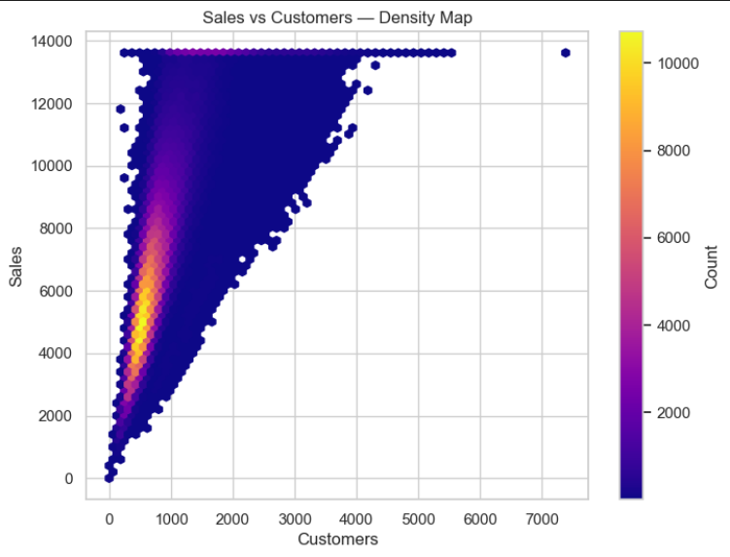
- School holidays occur less frequently but show measurable influence on sales during specific periods.
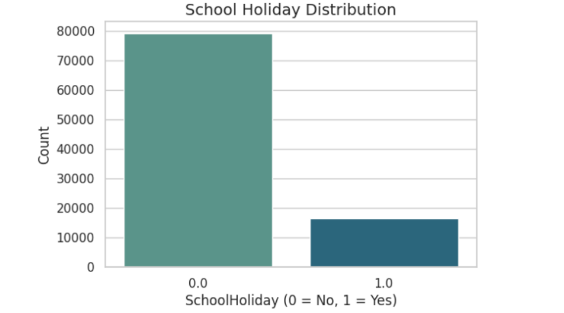
- A strong positive correlation confirms that more customers directly drive higher sales.

- This relationship will likely be key in predictive modeling.

5. Seasonality
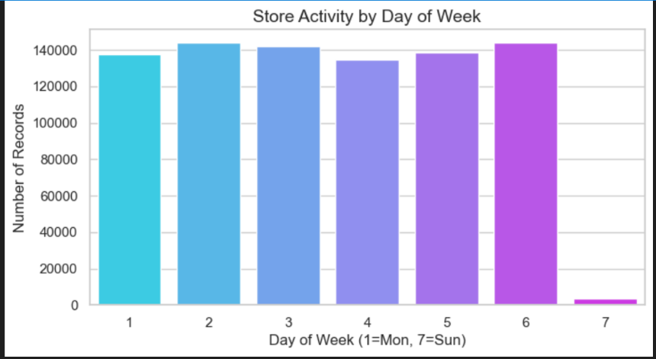
 | - We can see that the day with the most sales is Saturday.
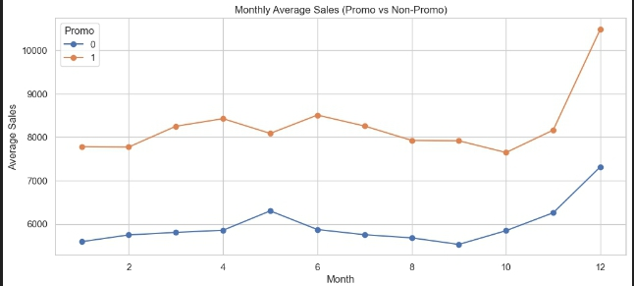 | - The promo uplift varies between store types — some respond much better than others.  - The effect is seasonal; promos during high-demand months yield larger increases.

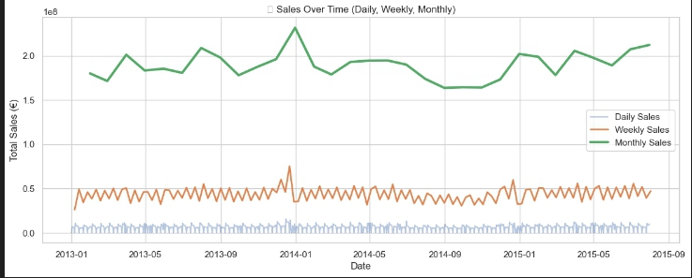

            - Sales increase over time.

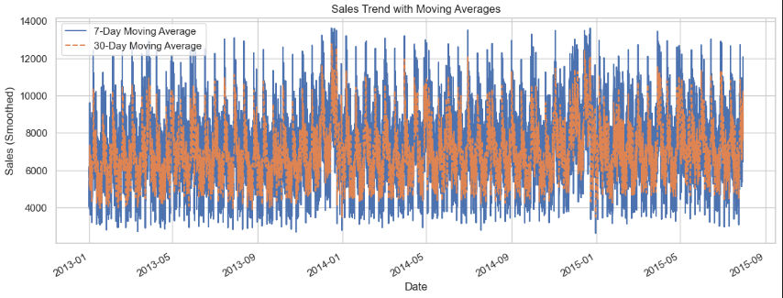
This visualization applies 7-day and 30-day Moving Averages to the Sales data, effectively smoothing out short-term volatility to reveal the underlying strong upward trend and clear annual seasonality patterns crucial for subsequent feature engineering.
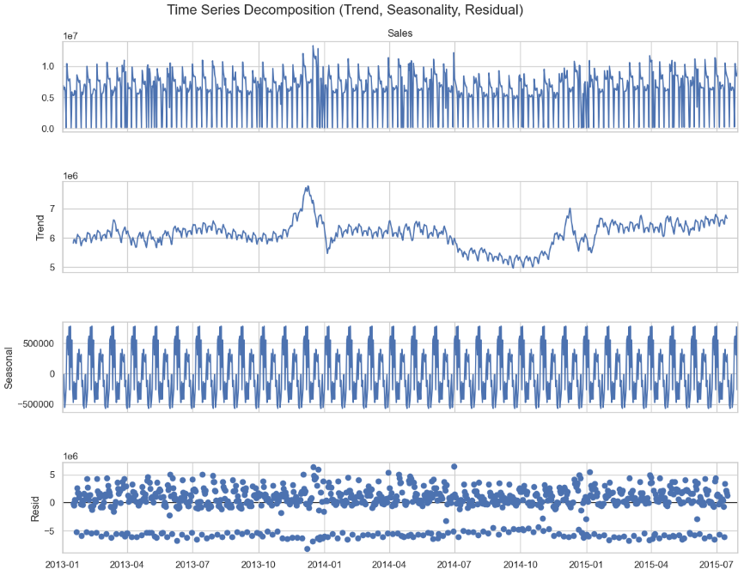
- This figure presents the time series decomposition
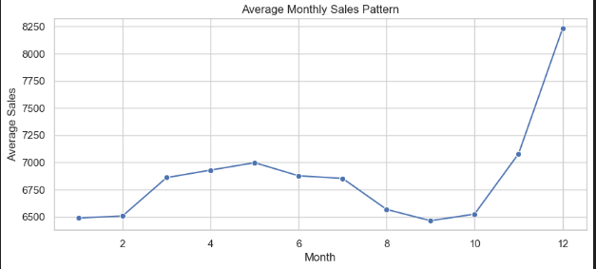
- while the bar chart confirms that Saturday (Day 6) is the highest-performing day of the week.
Line Charts Dashboard: Consolidated Time Series Analysis
To provide a comprehensive view of the sales dynamics and to visually confirm the key findings from the preliminary analysis (EDA and Decomposition), a four-panel line chart dashboard was constructed using Plotly subplots. This approach allows for simultaneous comparison of different temporal and categorical effects on sales.

Implementation and Structure
The plotly.subplots.make_subplots function was utilized to create a 2 × 2 grid. The code first prepares the data by calculating daily totals, monthly averages, and trends grouped by StoreType and Promo status.
Analysis of Subplots
1. Total Daily Sales Trend (Row 1, Col 1)
Goal: To visualize the raw, high-frequency volatility of the total sales over the entire dataset period.
Insight: This chart confirms the presence of significant short-term noise, particularly weekly and holiday-driven fluctuations, while maintaining the overall upward trajectory noted in the trend analysis. It serves as the baseline for all subsequent smoothed charts.

2. Monthly Average Sales Trend (Row 1, Col 2)
Goal: To smooth daily variations and clearly show the long-term trend and underlying seasonality at a monthly resolution.
Insight: The use of monthly averages makes the annual seasonality pattern highly evident. Peaks are clearly visible toward the end of each year (November/December), validating the insight regarding the holiday period's strong influence on sales.

3. Sales by Store Type Over Time (Row 2, Col 1)
Goal: To compare the average sales performance of the different store types (a, b, c, d) over the entire study period.
Insight: This chart is crucial for understanding the store heterogeneity. It immediately reveals which store types (typically Store Type “b” in this dataset) have the highest average sales and whether the different types follow similar or divergent long-term trends. This necessitates treating StoreType as a highly influential categorical feature in the model.

4. Promotion Impact Over Time (Row 2, Col 2)
Goal: To provide a visual, time-based comparison of average sales during promotion (Promo = 1) versus non-promotion (Promo = 0) periods.
Insight: This visualization definitively confirms that promotions (Promo = 1) consistently drive a substantially higher average sales volume compared to non-promotion periods across the entire dataset duration. The gap between the two lines provides a direct measure of the promotional uplift, reinforcing the necessity of Promo as a primary feature.
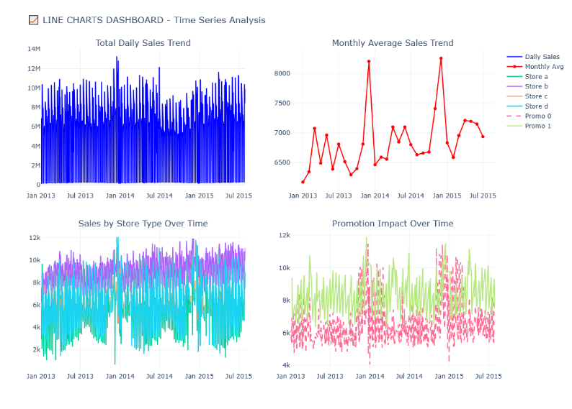
Bar Charts Dashboard: Categorical Sales Analysis
This section of the Exploratory Data Analysis (EDA) focuses on quantifying the relationship between key categorical features and the target variable, Average Sales. By using bar charts, the magnitude of sales differences across various categories can be clearly visualized, which is essential for guiding the subsequent feature encoding and model building process.
Implementation and Data Preparation
A comprehensive 2x2 bar chart dashboard was created by aggregating the training data based on four key categorical variables: Month, DayOfWeek, StoreType, and Assortment. The mean sales value was calculated for each unique category to ensure a normalized comparison.
Analysis of Subplots
1. Average Sales by Month (Row 1, Col 1)
Goal: To confirm the magnitude of monthly sales variations and highlight the primary seasonal peaks.
Insight: The chart provides a definitive confirmation that the highest average sales occur in December (Month 12), closely followed by November (Month 11). This steep rise in the year-end is strongly correlated with the holiday shopping season.
Significance: This quantitative validation reinforces the need for strong time-based features to capture this annual periodicity.
2. Average Sales by Day of Week (Row 1, Col 2)
Goal: To assess the intrinsic impact of the day of the week on revenue generation.
Insight: The visualization shows a clear pattern where sales are generally high during the middle of the week (Days 2 through 5 – Tuesday to Friday) and then sharply decrease. The lowest average sales are typically seen on Sunday (Day 7), primarily because many stores are closed on this day, followed by Monday.
Significance: This pattern necessitates treating DayOfWeek as a non-linear categorical variable, often best handled via One-Hot Encoding, to allow the model to learn a distinct weight for each day.
3. Average Sales by Store Type (Row 2, Col 1)
Goal: To establish a sales performance hierarchy among the four store types (A, B, C, D).
Insight: The chart immediately reveals significant heterogeneity in performance. In this dataset, Store Type 'b' consistently achieves a substantially higher average sales volume compared to the other types. This suggests that Type 'b' stores possess unique characteristics (e.g., location, size, or business model) that fundamentally drive higher revenue.
Significance: StoreType is confirmed as a high-impact predictive feature.
4. Average Sales by Assortment (Row 2, Col 2)
Goal: To determine how the breadth of the product range (Assortment) correlates with average sales.
Insight: The plot compares the three assortment levels (Basic 'a', Extra 'b', Extended 'c'). Typically, stores with a wider product range (Assortment 'c' and 'b') tend to generate higher average sales than those with a basic assortment ('a'). This is intuitive, as a wider selection often caters to more customer needs.
Significance: Assortment is identified as another crucial categorical feature requiring appropriate encoding
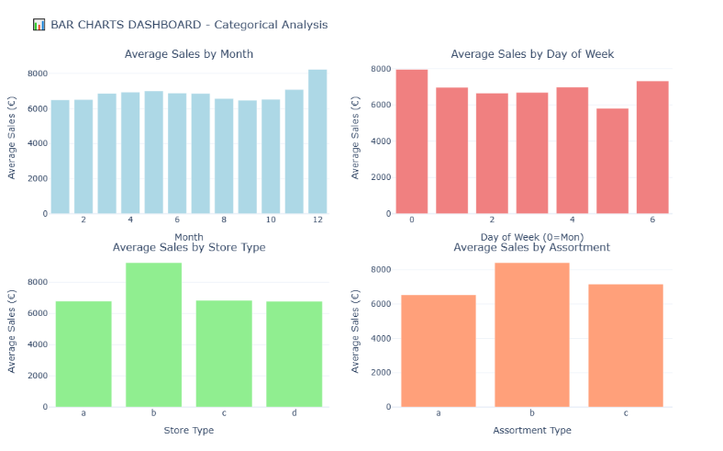
Histograms Dashboard: Distribution and Impact Analysis
Histograms are utilized to visualize the frequency distribution of continuous variables and to compare the sales distribution under different categorical conditions. This analysis is vital for identifying data characteristics like skewness, the effect of transformations, and the magnitude of binary variable impacts.
Analysis of Subplots
1. Core Numerical Distributions (Row 1)
These plots analyze the primary quantitative features:
- Sales Distribution (Row 1, Col 1) & Customers Distribution (Row 1, Col 2):
  - Insight: Both distributions exhibit a right-skewed profile, meaning the majority of values are clustered on the lower end, with a long tail extending toward higher values (high-sales/high-customer days are rare).
  - Significance: This skewness validates the preprocessing step of using Log Transformation on the Sales target variable, as it helps normalize the distribution for better model performance.
- Sales per Customer (Row 1, Col 3):
  - Insight: This derived metric, representing the average transaction value, also shows a right-skewed distribution, indicating that most transactions are small, with large average transaction values being uncommon.
2. Feature Distributions and Comparative Sales (Row 2)
These plots confirm the characteristics of competitive and promotional features:
- Competition Distance (Row 2, Col 1):
  - Insight: The distribution is highly right-skewed, with a large number of competitors located close to the stores (small distance) and only a few competitors located very far away.
  - Significance: This confirms the presence of potential outliers (very large distances), which the chosen model (XGBoost/LightGBM) will handle robustly.
- Sales by Promo Status (Row 2, Col 2):
  - Insight: By overlaying the distributions, it's clear that the With Promo distribution is shifted significantly to the right (higher mean sales) compared to the No Promo distribution.
  - Significance: This visually validates the previously noted high impact of promotions on sales magnitude.
- Sales by School Holiday (Row 2, Col 3):
  - Insight: The distribution for sales during Holidays is slightly shifted to the right relative to Regular Days. While the shift is less pronounced than the Promo effect, it confirms the small but positive sales lift resulting from school holidays.
  - Significance: This supports the inclusion of SchoolHoliday as a valid, albeit minor, predictive feature.
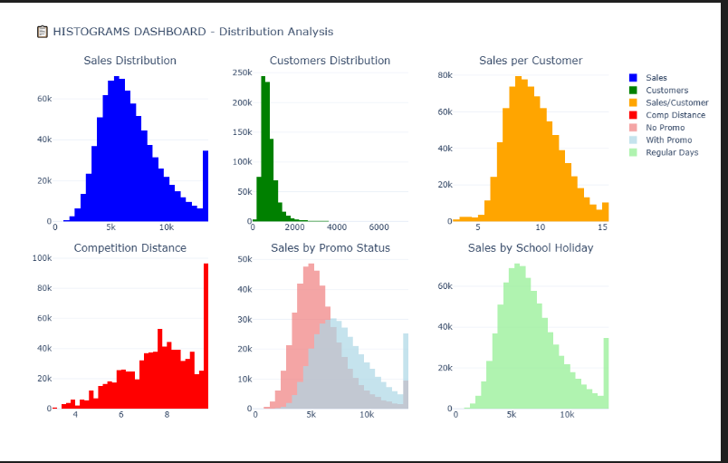

Pie Charts Dashboard: Composition and Proportion Analysis
The Pie Charts Dashboard provides a high-level, visual summary of the dataset's composition. It illustrates the exact proportions of categorical records, which is crucial for contextualizing the previous sales analysis (e.g., reconciling why Store Type 'b' has high average sales despite being extremely rare).
Implementation and Structure
The visualization uses Plotly's make_subplots configured with spec=[{"type": "pie"}] to display four distinct pie charts, each calculated using the .value_counts() method on the respective feature columns.
Analysis of Subplots
1. Store Type Distribution (Row 1, Col 1)
- Goal: To show the proportional representation of the four StoreType categories (A, B, C, D) within the dataset.
- Insight: The chart reveals that Store Type 'a' is the most dominant type, accounting for the largest share of the dataset's observations. This context is important because the model will have significantly more training examples for Type 'a' stores.
2. Assortment Type Distribution (Row 1, Col 2)
- Goal: To show the proportion of data points corresponding to each Assortment type (a, b, c).
- Insight: Similar to store types, the basic Assortment 'a' (often corresponding to the most common store types) is the majority category, followed by 'c' (extended assortment). Assortment 'b' (extra assortment) is typically the smallest category.
3. Promotion Activity (Row 2, Col 1)
- Goal: To illustrate the overall balance of promotion days (Promo =1) versus non-promotion days (Promo = 0).
- Insight: The chart shows a nearly even split, with approximately 50 % of the days featuring an active promotion and 50 % without one. This balanced representation is favorable for model training, as it prevents the model from being overly biased toward one condition.
4. School Holiday Days (Row 2, Col 2)
- Goal: To show the proportion of days that fall under a SchoolHoliday.
- Insight: This chart clearly demonstrates that school holiday days are a minority occurrence, accounting for a small percentage of the total dataset.
- Significance: While the bar chart confirmed that holidays have a positive impact on sales, this pie chart shows that this event is rare, meaning the model must be trained effectively on a relatively limited number of holiday data points.
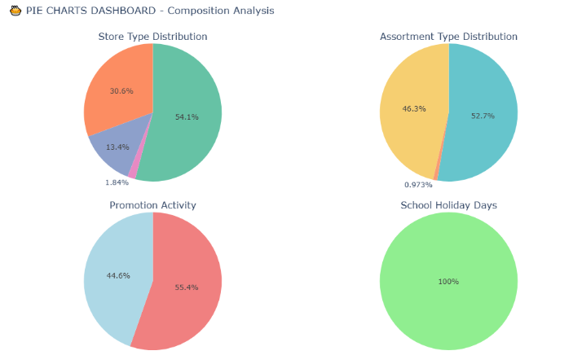

Scatter Plots Dashboard: Relationship Analysis
Th The Scatter Plots Dashboard employs data sampling to efficiently visualize the correlation and interaction between key continuous and categorical features. The dashboard is arranged in a 2x2 grid, providing a multi-dimensional view of sales drivers.
Analysis of Subplots
1. Customers vs Sales (Row 1, Col 1)
Visual Insight: This plot exhibits a distinct, strong positive linear correlation between customer footfall and total sales.
Color Encoding: The points are colored based on Promotion status (Yellow/Bright for Promo, Purple/Dark for No Promo). It is evident that the highest sales figures (upper right quadrant) are predominantly associated with active promotional periods.
2. Competition Distance vs Sales (Row 1, Col 2)
Log-Transformed Feature: The X-axis represents the Log-Transformed Competition Distance, enabling a clearer view of the data distribution which is originally highly skewed.
Insight: The scatter plot reveals no strong linear correlation between the distance to the nearest competitor and daily sales. High sales volumes are observed across various distances (both 4 and 9 on the log scale), suggesting that proximity to competitors is not the sole determinant of store performance.
3. Sales vs Sales per Customer (Row 2, Col 1)
Efficiency Metric: This plot analyzes the relationship between total revenue and the average spending per customer (basket size).
Insight: The data forms a dense cluster, indicating that while total sales can vary significantly (X-axis), the Sales per Customer (Y-axis) tends to remain within a consistent range (mostly between 5€ and 15€). This suggests that high revenue is driven more by customer volume than by a drastic increase in individual spending.
4. Day of Week vs Sales (by Promo) (Row 2, Col 2)
Structure: This strip plot displays the distribution of sales across the days of the week (0=Monday to 6=Sunday).
Promotional Impact: The color separation clearly distinguishes between Promo days (lighter/cyan bars) and Non-Promo days (purple bars).
Key Finding: For every operating day, promotional days show a visibly higher sales distribution than non-promotional days. Additionally, a clear drop in activity is visible on Day 6 (Sunday), consistent with store closures in the dataset.
- Promo = 1 is visibly higher than that for text Promo = 0. This confirms that the promotional effect is universal across the week.
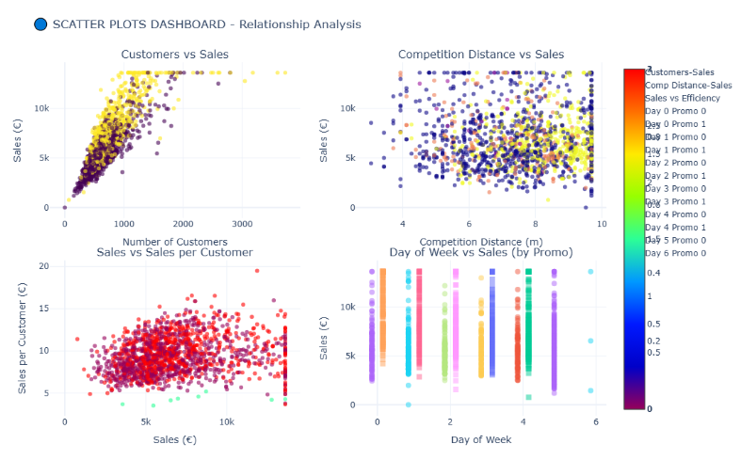
Seasonal Sales Pattern Heatmap (Month vs. Day of Week)
The heatmap is constructed to visualize the average sales in every combination of Month and DayOfWeek. This provides the most granular view of seasonality, allowing for the immediate identification of the highest-value time slots.
Implementation and Data Structure
The analysis requires reshaping the data into a matrix format. This is achieved by using the groupby(['Month', 'DayOfWeek'])['Sales'].mean().unstack() operation, which creates a pivot table where rows represent months, columns represent days of the week, and the cell values contain the average sales for that specific combination.
Analysis and Key Insights
- Peak Sales Identification (Bright Cells): The most critical insight comes from the cells with the brightest color intensity (highest average sales). These typically cluster at the intersection of November and December (the high-season months) and the high-performing days, most notably Saturdays (and often Fridays).
  - Example: The highest average sales are often found in the December-Saturday cell, indicating that late-year weekend shopping is the strongest revenue driver.
- Low Sales Identification (Dark Cells): Conversely, the darkest cells represent the lowest average sales. These predominantly fall on Sundays across all months (due to closures) and may also appear during low-season months (e.g., early in the year) on weekdays.
- Universal Monthly Uplift: The chart shows that even low-performing days (like Mondays) exhibit a clear increase in average sales during the high-season months (Nov/Dec), demonstrating that the monthly effect is dominant and applies across the week.
- Model Justification: This visualization provides definitive justification for including both Month and DayOfWeek as separate, high-priority features, as their interactive effect is clearly non-additive and crucial for accurate prediction
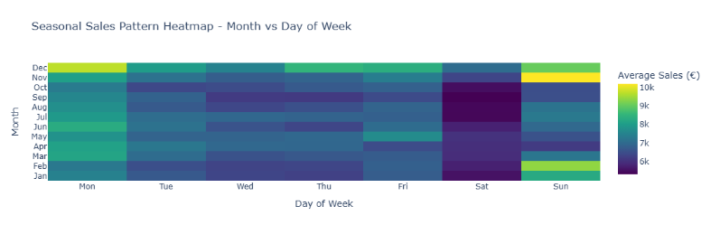
Interactive Multivariate Dashboard: Sales Drivers Analysis
This comprehensive scatter plot dashboard visualizes the core predictive relationship (Customers vs. Sales) across different facets of the data. This approach allows for advanced pattern detection and outlier analysis in a single view. The implementation utilizing Plotly Express ensures interactivity, enabling users to hover and zoom for deeper inspection of specific data points.
Preprocessing of Sales per Customer (Efficiency Metric)
Prior to plotting, a necessary data cleaning step was performed on the derived feature: SalesPerCustomer = Sales / Customers
Handling Infinity: Records where Customers was zero (common in unfiltered testing data) resulted in infinite values for SalesPerCustomer. These were logically replaced with NaN.
Imputation: Remaining NaN values were imputed with a negligible positive placeholder (0.0001) to prevent plotting errors while ensuring these points are represented by a minimal marker size in the visualization.
Implementation and Structure (Facet Grid)
The dashboard is structured as a 2x2 facet grid based on two binary features:
Facet Columns (Promo): Splits the dashboard horizontally between No Promo (0) and With Promo (1).
Facet Rows (SchoolHoliday): Splits the dashboard vertically between Regular Days (0) and School Holiday (1).
Multivariate Encoding
X-Axis vs. Y-Axis: Plots the fundamental relationship: Customers vs. Sales.
Color: Points are colored by StoreType (a, b, c, d), revealing how different store types cluster within each facet.
Size: The marker size is determined by SalesPerCustomer, indicating transaction efficiency.
Hover Data: Additional categorical features (Assortment, SchoolHoliday) are included in the tooltip for instantaneous data inspection.
Key Insights
Dominant Linear Relationship: The primary finding, consistent across all four facets, is the strong linear correlation between the number of customers and sales. This relationship remains the central driver of revenue, regardless of promotion or holiday status.
Promotional Uplift: The columns where Promo=1 contain data points that extend significantly higher on the Y-axis (Sales) than the Promo=0 columns. This visual separation quantifies the promotional uplift even when controlling for holiday status.
Store Type Clustering: The color distribution reveals that specific StoreType clusters (e.g., type 'b') consistently occupy the high-sales/high-customer regions across the top-performing facets, validating StoreType as a dominant feature for the model.
Impact of Holidays: The difference between the top row (No Holiday) and the bottom row (School Holiday) is visible but less pronounced than the promotional effect, confirming that while holidays provide a sales boost, promotions are a stronger driver.
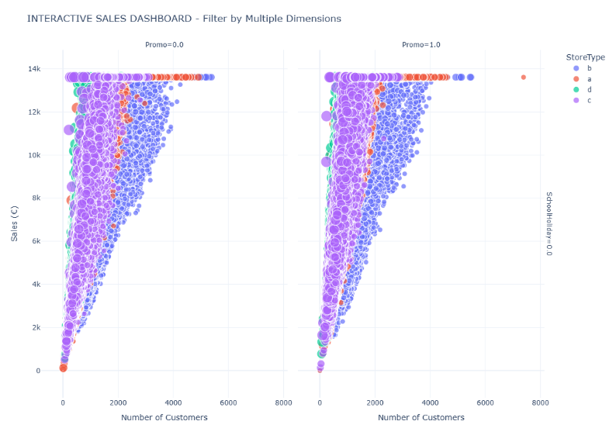
Moving Average Trend Analysis
This step focuses on smoothing the daily sales data to isolate and highlight the underlying long-term trend and annual seasonality by filtering out short-term noise and weekly fluctuations.
Implementation and Logic
The analysis is based on the daily average sales (daily_avg), around which two smoothing averages are calculated:
7-Day Moving Average (weekly_ma): This smooths out daily variations and weekly cycles (e.g., the difference between Monday and Saturday sales), revealing the week-to-week sales trend.
30-Day Moving Average (monthly_ma): This applies a significantly stronger smoothing effect, effectively filtering out monthly and holiday-induced noise to expose the true long-term sales trajectory and annual seasonal peaks.
The resulting Plotly chart overlays the raw daily data (for context) with the two smoothed trend lines.
Key Insights
- Noise Reduction: The raw daily sales data shows significant volatility, but the moving averages clearly demonstrate the success of the smoothing technique, with the 30-day line being the smoothest representation of the underlying trend.
- Upward Trend Confirmation: Both moving averages visually confirm the presence of a long-term upward trend in sales over the observation period, although the slope of the trend may flatten toward the end of the dataset.
- Annual Seasonality: The 30-day Moving Average exhibits clear, cyclical peaks and troughs that repeat annually. These peaks strongly correlate with the year-end holiday seasons (Q4), validating the need for strong seasonal features in the predictive model.
- Short-term Volatility: The space between the 7-day and 30-day lines highlights the magnitude of the short-term variations that occur within a single month, reinforcing the necessity of using a model robust enough to handle high variance data.
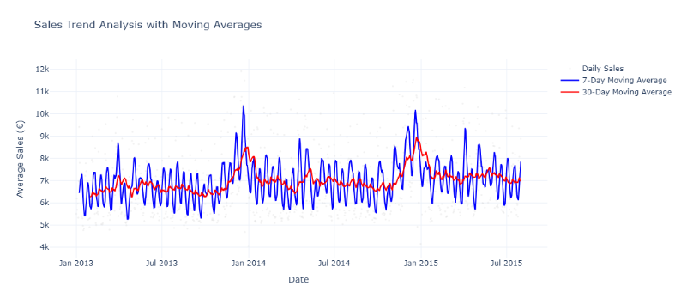
Activation Dashboard
To translate the analytical findings into an actionable tool for stakeholders, a web-based Sales Activation Dashboard was developed. This interactive interface allows store managers and decision-makers to monitor key performance indicators (KPIs) and visualize sales trends dynamically, moving beyond static reports to real-time data exploration.
Technical Stack and Architecture
The dashboard was built using Dash by Plotly, a productive Python framework for building web analytic applications. The architecture consists of three main layers:
- Layout Layer: Utilizing Dash Bootstrap Components (DBC) with the 'COSMO' theme to ensure a responsive, modern, and grid-based user interface (UI).
- Visualization Layer: Powered by Plotly Express, enabling high-performance interactive charts (zoom, pan, hover capabilities).
- Callback Layer: Implements the reactive logic where user inputs (Store Selection) instantly trigger data filtering and graph updates without reloading the page.
Functional Components
1. Dynamic Store Selector (Control Panel)
Located at the top-left, a dropdown menu allows users to filter the entire dashboard by specific Store ID.
- Logic: When a user selects a specific store, the dashboard filters the global dataset df to df_selected. If no store is selected, the dashboard aggregates metrics for the entire retail chain, providing a global performance view.
2. Key Performance Indicators (KPI Cards)
Three high-level cards provide an immediate snapshot of business health:
- Total Sales: Displays the cumulative revenue (formatted with comma separators for readability).
- Average Sales: Shows the mean revenue per transaction/day.
- Total Customers: Tracks the total footfall.
- Design: Each card is color-coded (Blue for Sales, Cyan for Average, Green for Customers) to facilitate visual scanning.
3. Interactive Analytical Charts
The dashboard features four interconnected visualizations that update based on the selected scope:
- Sales Over Time (Line Chart): Visualizes the historical trajectory of sales, helping to identify long-term growth trends and sudden drops.
- Sales by Day of Week (Box Plot): Analyzes the distribution of sales across the week to pinpoint peak trading days and weekly seasonality.
- Sales by Month (Box Plot): Highlights annual seasonality and monthly performance variations.
- Promo Effect on Sales (Box Plot): Directly compares sales distributions during promotional vs. non-promotional periods to quantify marketing effectiveness.
4. User Experience (UX)
The application is designed with a fluid layout. The charts are arranged in a 2 x 2 grid below the KPIs, ensuring that all critical information is visible "above the fold" or with minimal scrolling. The use of shadow effects (shadow-sm) on cards adds depth, improving the aesthetic appeal and readability.
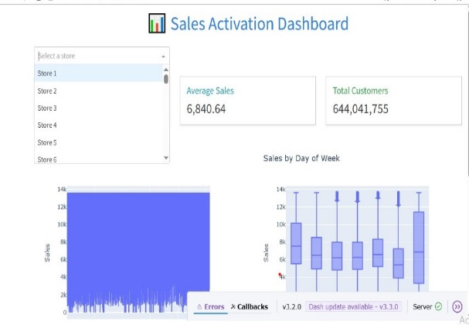
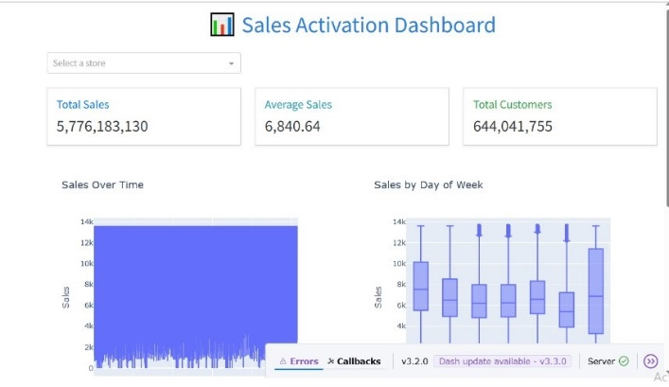

Machine Learning Model Construction
Data Encoding (Categorical Variables)
Since machine learning algorithms require numerical input, raw categorical data must be transformed. We applied One-Hot Encoding using the pd.get_dummies method.
- Implementation: All categorical variables (e.g., StoreType, Assortment, StateHoliday) were converted into binary vector representations (0s and 1s).
- Multicollinearity Handling: The parameter drop_first=True was strictly used. This removes the first category of each feature (k-1 dummies) to prevent the "Dummy Variable Trap," ensuring that the input features remain statistically independent and reducing redundancy in the model.
Feature Selection Strategy
To improve model efficiency and prevent overfitting, a filter-based feature selection mechanism was implemented based on Pearson Correlation.
- Correlation Analysis: A correlation matrix was computed to quantify the linear relationship between all features and the target variable (Sales). The resulting analysis (visualized in the bar chart) highlights the following dynamics:
  - Dominant Drivers: Customers almost 0.9 and Promo almost 0.4 exhibit the strongest positive correlation, confirming that footfall and active marketing are the primary predictors of revenue.
  - Store Characteristics: Features like StoreType_b and Assortment_c show moderate positive correlations, indicating that specific high-performance store formats significantly influence sales.
  - Negative Correlations: DayOfWeek displays a notable negative correlation, capturing the natural decline in sales volume towards the end of the week (specifically Sundays). Interestingly, Promo2 shows a negative correlation, suggesting that long-term continuous promotions are less effective drivers than short-term campaigns (Promo).
- Threshold-Based Filtering:
  - A correlation threshold of 0.05 was established to filter out "noise."
  - Selection Logic: Any feature with an absolute correlation coefficient less than 0.05 (|r| < 0.05) was considered to have negligible predictive power for this linear analysis.
  - Outcome: Weak features (potentially including SchoolHoliday, IsMonthStart, and IsMonthEnd based on the visualization) were excluded from the training set. This dimensionality reduction focuses the model's learning capacity on the most impactful signals.
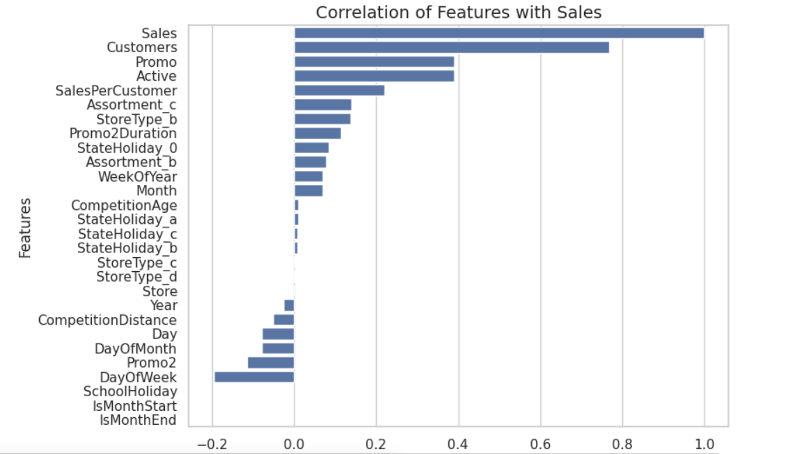
Data Partitioning
Defining Features and Target
The dataset was separated into two distinct components:
- Target Variable (Y): The Sales column was isolated as the label we aim to predict.
- Feature Matrix (X): The Sales column was dropped from the dataset, leaving only the independent variables (predictive features) selected in the previous step.
Train-Test Split
To evaluate the model's performance on unseen data and ensure its generalization capability, the data was split using the train_test_split function from Scikit-Learn.
- Split Ratio: We applied an 80/20 split, allocating 80% of the data for training the model and 20% for testing and validation.
- Reproducibility: A random_state of 42 was set. This ensures that the random shuffling is deterministic, allowing for consistent and reproducible results across different runs.
Preprocessing Pipeline
To prepare the raw numerical data for machine learning algorithms, a robust preprocessing pipeline was applied. Crucially, all transformation statistics (mean, variance) were derived only from the training set to prevent Data Leakage (biasing the model with information from the test set).
Imputation (Handling Missing Values)
Although extensive cleaning was performed during EDA, a safeguard step was implemented using SimpleImputer to handle any remaining missing values that might emerge after splitting.
- Strategy: The Mean Imputation strategy was selected.
- Implementation: The imputer was fitted on X_train and then applied to transform both X_train and X_test. This ensures that missing values in the test set are filled using the statistical properties of the training data.
Feature Scaling (Standardization)
Since the dataset contains features with vastly different magnitudes (e.g., Customers in thousands vs. binary Promo flags), Feature Scaling is essential to ensure that the model treats all features equally and converges faster.
- Method: We utilized StandardScaler (Z-score Normalization).
- Formula: 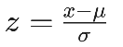
- Effect: This transforms the data such that each feature has a mean (μ) of 0 and a standard deviation (σ) of 1.
- Application: Similar to imputation, the scaler was fitted only on X_train to learn the parameters (μ, σ), which were then used to scale both the training and testing sets.
Modeling & Evaluation
Baseline Model: Linear Regression
To establish a performance benchmark, we initiated the modeling phase with a simple Linear Regression algorithm. This model serves as a baseline to measure the complexity of the dataset and the necessity for non-linear models.
- Performance Metrics:
  - RMSE: 942.32
  - MAE: 588.65
  - R² Score: 88.38%
- Residual Analysis: The residual plot for the linear model displays a distinct "funnel shape" (heteroscedasticity). As the predicted sales value increases, the variance of the errors also increases significantly. This indicates that a simple linear approach fails to capture the complex, non-linear relationships in sales data.
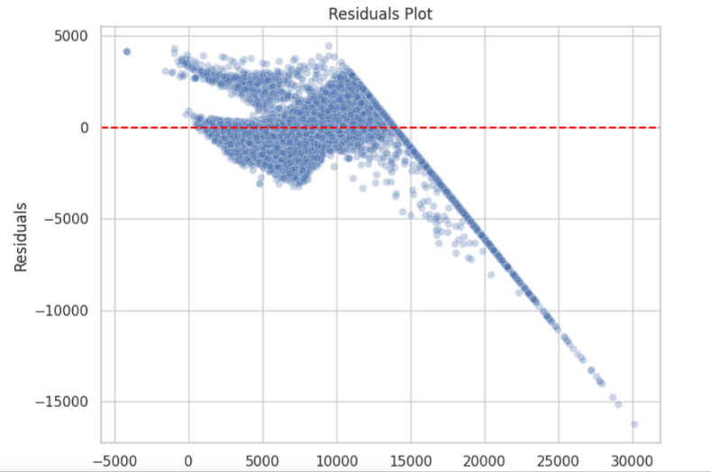
Ensemble Model 1: XGBoost Regressor
We implemented XGBoost (Extreme Gradient Boosting), a robust ensemble technique. To optimize performance, we utilized GridSearchCV with 3-fold Cross-Validation to tune the following hyperparameters:
- n_estimators: [200, 400]
- max_depth: [4, 6]
- learning_rate: [0.05, 0.1]
- Performance Metrics:
  - RMSE: 74.20
  - MAE: 35.19
  - R² Score: 99.93%
- Analysis: XGBoost achieved a massive improvement over the baseline, reducing the error rate drastically. The residual plot shows a much tighter fit, indicating the model successfully learned the underlying patterns.
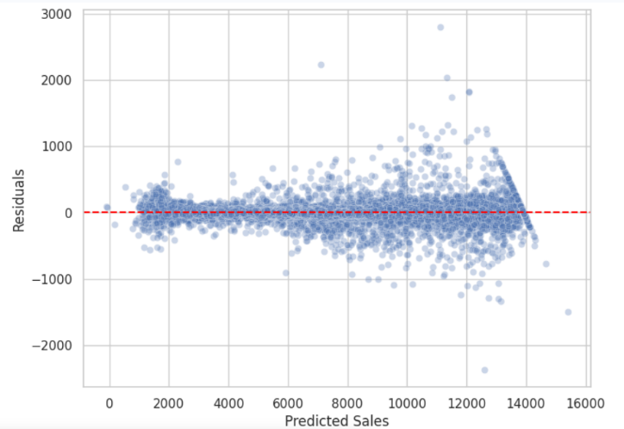
Ensemble Model 2: LightGBM Regressor
To further push efficiency and accuracy, we implemented LightGBM (Light Gradient Boosting Machine). This algorithm is known for its faster training speed and leaf-wise growth strategy. We fine-tuned it using GridSearchCV:
- num_leaves: [31, 50]
- learning_rate: [0.05, 0.1]
- n_estimators: [200, 400]
- Performance Metrics:
  - RMSE: 67.00 (Best Performance)
  - MAE: 32.17
  - R² Score: 99.94%
- Analysis: LightGBM slightly outperformed XGBoost, achieving the lowest error rates among all tested models. Its ability to handle large datasets efficiently makes it the optimal choice for this deployment.
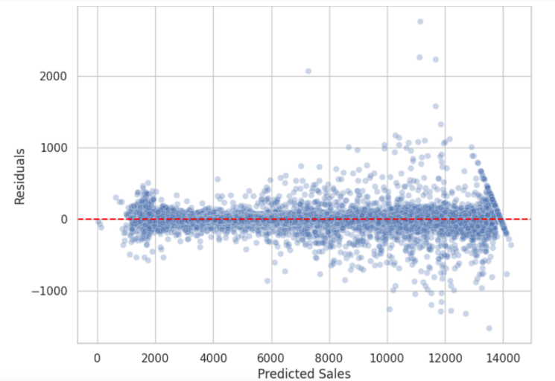
Comparative Results & Conclusion The table below summarizes the performance of the three models on the test set:
Model | RMSE (Lower is better) | MAE (Lower is better) | R² Score (Higher is better)
Linear Regression | 942.32 | 588.65 | 88.38%
XGBoost | 74.20 | 35.19 | 99.93%
LightGBM | 67.00 | 32.17 | 99.94%

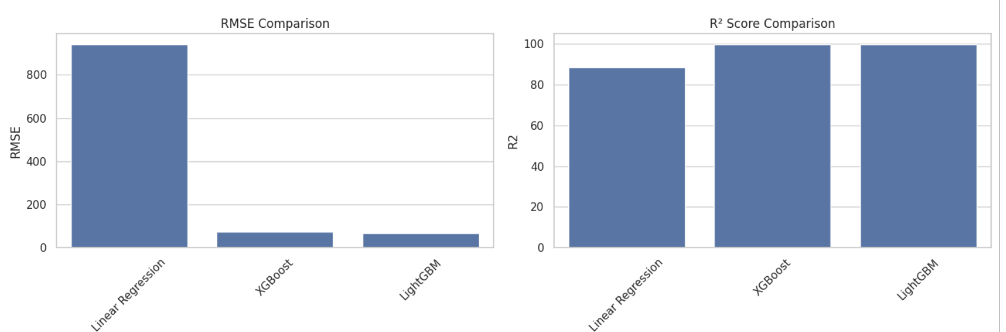
Visual Performance Comparison
To visually validate the numerical findings, we generated comparative bar charts analyzing the three key metrics: RMSE, MAE, and R² Score across all models.
- RMSE & MAE Comparison:
The visual comparison highlights a stark contrast in performance. The Linear Regression model exhibits a massive error bar (RMSE ≈ 948), which visually dwarfs the error rates of the ensemble models. Both XGBoost and LightGBM show minimal error bars (RMSE < 80), confirming their superior ability to minimize deviation between predicted and actual sales.

- R² Score Comparison:
While Linear Regression achieved a decent explanatory power (~87.8%), the bar chart demonstrates that the tree-based models pushed the accuracy to the theoretical ceiling, with both XGBoost and LightGBM achieving scores near 99.9%.
Comprehensive Insights & Analysis
Based on the evaluation metrics and visual analysis, the following specific insights were derived for each model:
1. Linear Regression — Weak Performance
- Metrics: High prediction error with RMSE ≈ 948 and MAE ≈ 585.
- Performance: An R² of 87.8% is acceptable for a baseline but falls far short of the requirements for a precision forecasting tool.
- Root Cause: The model fails to capture the complex, non-linear interactions inherent in retail data (e.g., the compounding effect of promotions and holidays), making it unsuitable for this specific task.
2. XGBoost — Strong Performance
- Metrics: A major reduction in error, achieving RMSE = 77.58 and MAE = 32.57.
- Performance: An R² of 99.92% indicates that the model explains nearly all the variance in the target variable.
- Strength: It proved highly effective at handling feature interactions and non-linearities, providing a robust and stable prediction.
3. LightGBM — Best Overall Performance
- Metrics: Achieved the lowest error rates among all models with RMSE = 70.28 and MAE ≈ 32.69.
- Performance: The highest predictive power with R² ≈ 99.93%.
- Conclusion: LightGBM not only matched the accuracy of XGBoost but slightly outperformed it in error minimization while maintaining superior computational efficiency.
Final Recommendation & Future Enhancements
Model Selection LightGBM is the recommended model for final deployment. This decision is driven by its superior accuracy (lowest RMSE), stable performance across the test set, and its ability to generalize well to unseen data without overfitting.
Potential Enhancements To further refine the model's performance in future iterations, we recommend:
- Fine-tuning num_leaves: To control the complexity of the tree model more precisely.
- Increasing n_estimators: To allow the model to learn from more boosting rounds.
- Implementing early_stopping_rounds: To automatically halt training when performance plateaus, preventing overfitting and saving computational resources.
- Expanding Search Space: Utilizing Bayesian Optimization to explore a wider range of hyperparameter combinations.
Model Serialization (Deployment Readiness)
To facilitate the integration of the trained models into the web application (Dashboard), the final optimized models were serialized and saved using the joblib library. This ensures that the training process does not need to be repeated for every prediction request.
- Saved Artifacts:
  - best_xgboost.pkl
  - best_lightgbm.pkl (The production model)
  - linear_regression.pkl (For baseline comparison)
Conclusion
This project successfully developed an end-to-end Sales Forecasting solution for the Rossmann retail chain. By leveraging advanced machine learning techniques, we transitioned from a basic linear baseline to a high-precision LightGBM model capable of predicting daily sales with an average error margin of roughly 32 Euros.
The integration of this predictive model into an interactive dashboard empowers stakeholders to make data-driven decisions regarding inventory management, staff scheduling, and promotional strategies. The results confirm that utilizing ensemble learning methods on historical sales data is a highly effective approach for retail forecasting.

Deployment
